**Sales Report with ROLLUP**

**Name :-** Satyajeet Sanjay Lokare.

**Solution :-**

**SELECT**

**ISNULL(ProductCategory, 'Total') AS ProductCategory,**

**ISNULL(ProductName, 'Total') AS ProductName,**

**SUM(SaleAmount) AS TotalSales**

**FROM Sales**

**GROUP BY ROLLUP (ProductCategory, ProductName)**

**ORDER BY**

**ProductCategory,**

**ProductName;**

**Output :-**

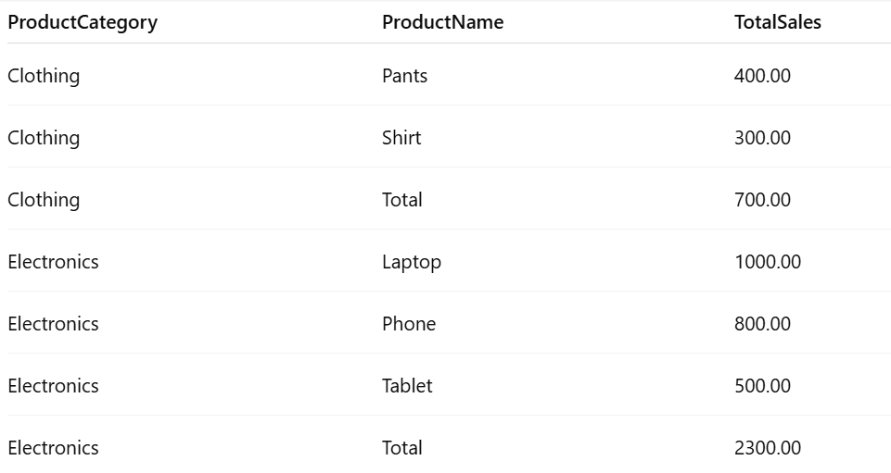

**Explanation :-**

* GROUP BY ROLLUP (ProductCategory, ProductName) generates:
  + Totals per product within each category.
  + Subtotals per category (ProductName = NULL).
  + Grand total (ProductCategory and ProductName = NULL).
* ISNULL(..., 'Total') replaces NULL with "Total" for readability.
* SUM(SaleAmount) aggregates sales data.